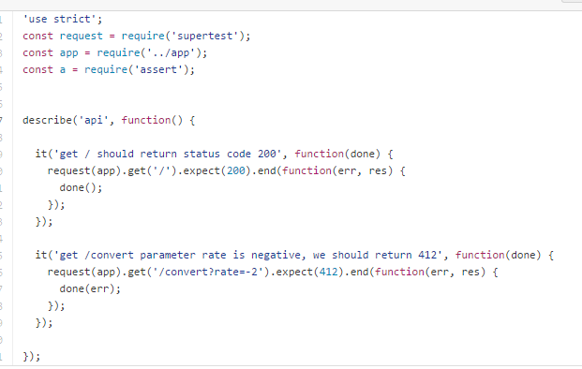

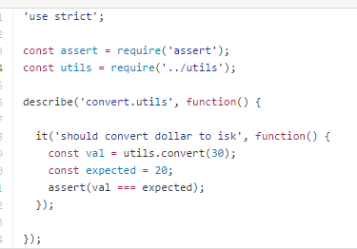

**Asynchronous: We accept done**.. and call it after the test.. mocha knows to wait for it.

Create a small program to test..

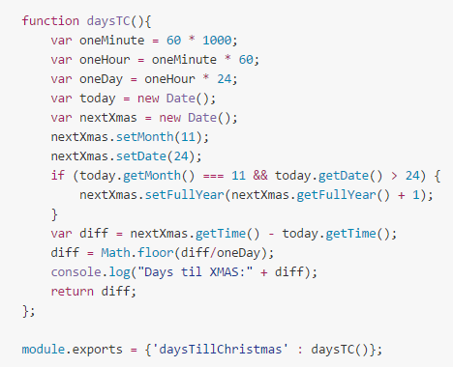

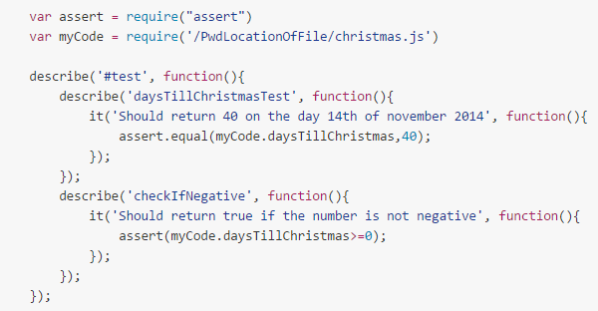

**First describe:** Names test suite

Within it you can describe other tests.. the second is the name of a specific test..

Fyrirlestur:

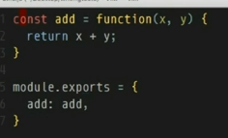 í utils.js

Gerum test_utils skrá.. náum í þessa utils skrá.. og assert..

